What is Microservices

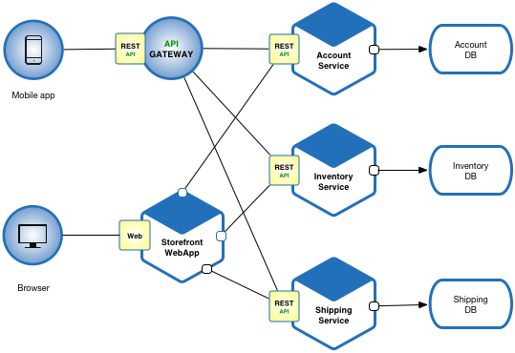

Which topic’s we will cover in this article:

1. What is micro service?
2. What is Monolithic Architecture?
3. Monolithic v/s Micro Service’s?
4. Advantages and Disadvantages of Micro Service?
5. Challenges of Micro Service’s?
6. Principles of Micro Services?

What is Micro Service:

Micro Services are the small services which work’s together. In this service one application or website is developed in different-different modules or services.

For example:

In E-commerce web site or in any web site we develop in micro services then modules are different who communicate with each other via link like login is different, register module is different, cart module is different, etc.



What is Monolithic Architecture:

If all the functionalities of a project exist in a single codebase, then that application is known as a monolithic application.

We all must have designed a monolithic application in our lives in which we were given a problem statement and were asked to design a system with various functionalities.

We design our application in various layers like presentation, service, and persistence and then deploy that codebase as a single jar/war file.

This is nothing but a monolithic application, where **“mono”**represents the single codebase containing all the required functionalities.

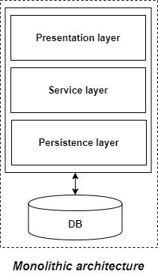

Monolithic Architecture v/s Micro Service Architecture:

|  |  |
| --- | --- |
| Monolithic | Micro Service’s |
| All functionalities of project is exists only in single codebase is know as monolithic architecture. | Here all functionalities are in different modules this code is Loosely coupled. |
| we can able to use only one technology. | In this service technology diversity is present. |
| Code is depend upon each other and deployment is difficult. | Here code is not depend upon each other and deployment is independent i.e we can deploy each module separate. |
| If any Bug is present in code then hole system is going to shut down. | Here any Bug is present in code than only that module will shut down but another modules are run fine. |

Advantages of Micro Service:

1. Easy to manage.
2. If we want to update in any one module then we don’t need to deploy hole application we have to just deploy that one module only.
3. Micro service deployment is independently.
4. Each micro service can use different technologies as per requirement.
5. Technology diversity is Vast in microservice.

Disadvantages of Micro Service:

1. This much more complex than monolithic architecture, because of distributed system.
2. Skilled developer’s are required to work with micro service architecture.
3. Independent deployment of micro service is complex.
4. Micro service is less secure than monolithic architecture because of inter service communication.

Challenges in Micro Service:

* Bounded Context
* Dynamic Scale up and Scale Down
* Monitoring
* Fault Tolerance
* Cyclic dependencies
* DevOps Culture

Principles of Micro Service:

1. Single Responsibility.
2. Built Around Business Capabilities.
3. Design for Failure.